THE TRAGEDY OF FLIGHT : A COMPREHENSIVE CRASH ANALYSIS

1.INTRODUCTION

1.1.OVERVIEW

Accidents in air transport are dominated by the failure of human factor failure, i.e. that of the aircrew. Despite of a positive development in the trend of accidents recorded since the beginning of the 21st century , the number of air accidents is still insatisfactory. Consequently, it is of paramount importance to do everything that would contribute to substantial reduction of the human factor failure in air transportation.

1.2.PURPOSE

**1. Fly on Nonstop Routings**

Most accidents occur during the takeoff, climb, descent, and landing phase of flight so flying nonstop would reduce exposure to these most accident prone phases of flight.

**2. Choose Larger Aircraft**

Currently, aircraft with more than 30 passenger seats were all designed and certified under the strictest regulations. Also, in the unlikely event of a serious accident, larger aircraft provide a better opportunity for passenger survival.

**3. Pay Attention to the Preflight Briefing**

Although the information seems repetitious, the locations of the closest emergency exits may be different depending on the aircraft that you fly on and seat you are in.

**4. Keep the Overhead Storage Bin Free of Heavy Articles**

Overhead storage bins may not be able to hold very heavy objects during turbulence, so if you or another passenger have trouble lifting an article into the bin, have it stored elsewhere.

**5. Keep Your Seat Belt Fastened While You are Seated**

Keeping the belt on when you are seated provides that extra protection you might need if the plane hits unexpected turbulence.

**6. Listen to the Flight Attendants**

The primary reason flight attendants are on an aircraft is for safety, so if one of them asks you to do something like fasten your seat belts, do it first and ask questions later.

**7. Don’t Bring Any Hazardous Material**

There are rather long lists of hazardous materials that are not allowed, but common sense should tell you that you shouldn’t bring gasoline, corrosives, poisonous gases, and other such items on the aircraft unless they were allowed by the airline and shipped in a proper container.

**8. Let the Flight Attendant Pour Your Hot Drinks**

Flight attendants are trained to handle hot drinks like coffee or tea in a crowded aisle on a moving aircraft, so allow them to pour the drink and hand it too you.

2. PROBLEM DEFINITION AND DESIGN THINKING

2.1.EMPATHY MAP

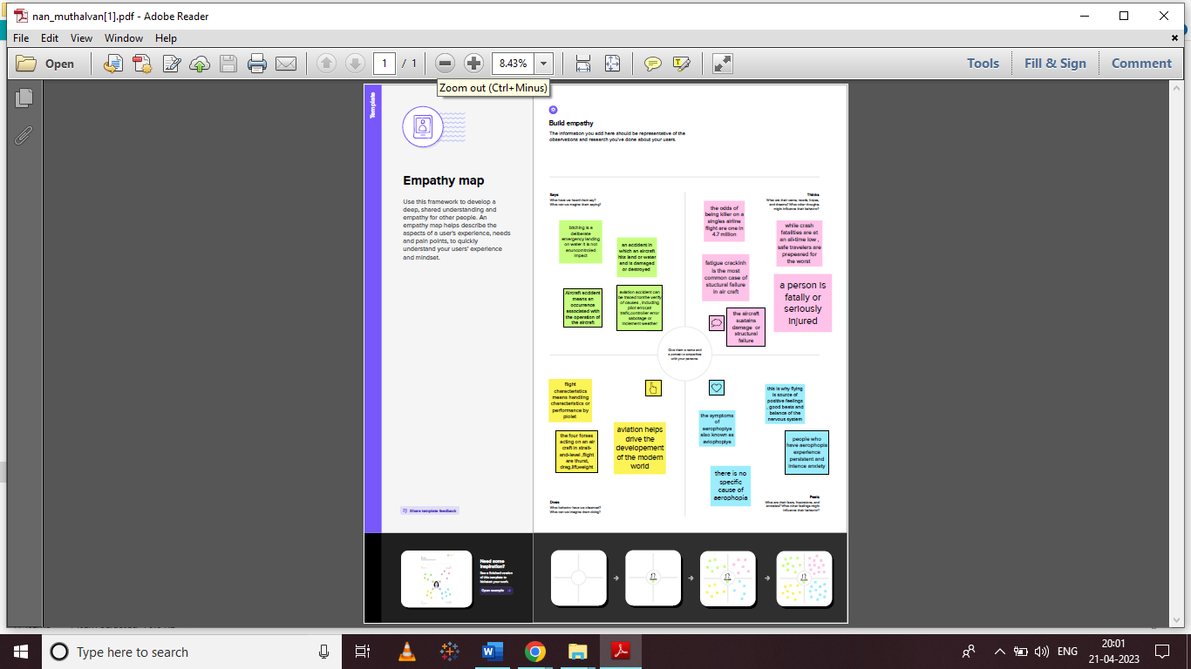

2.2.IDEATION AND BRAINSTROMING MAP

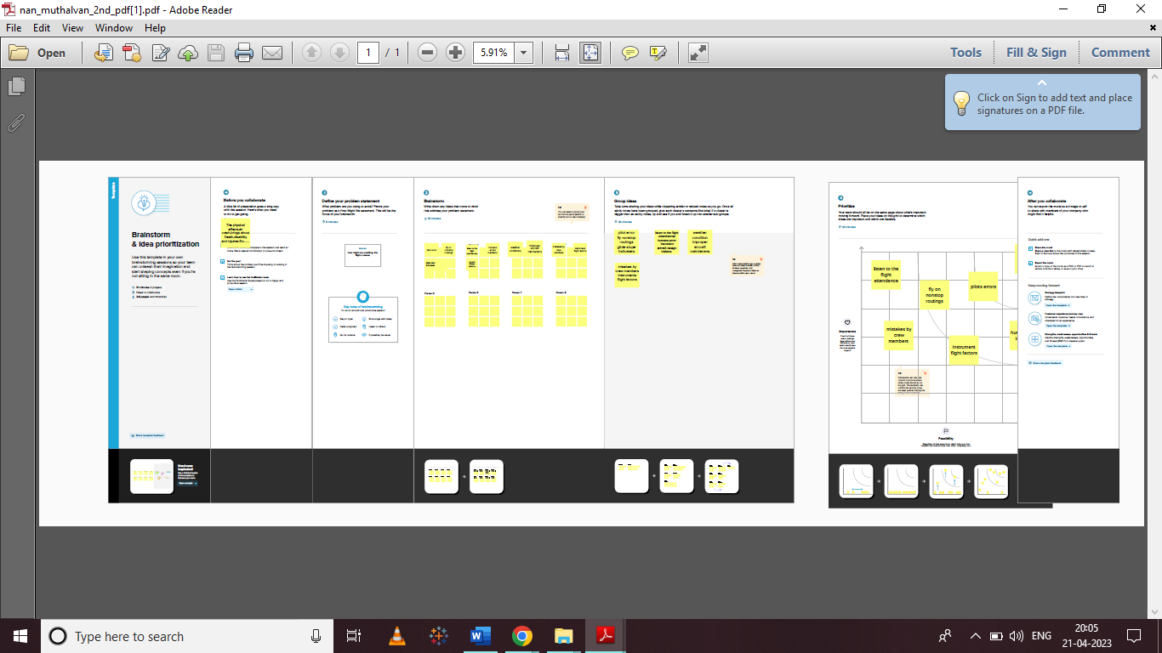

3.RESULT

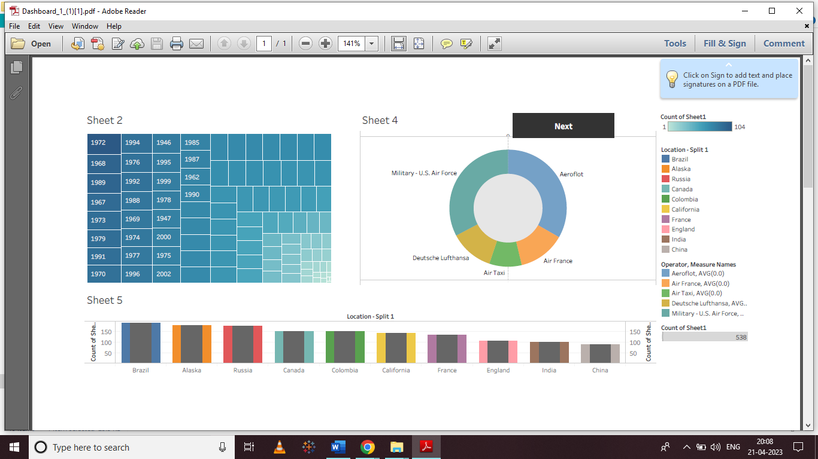

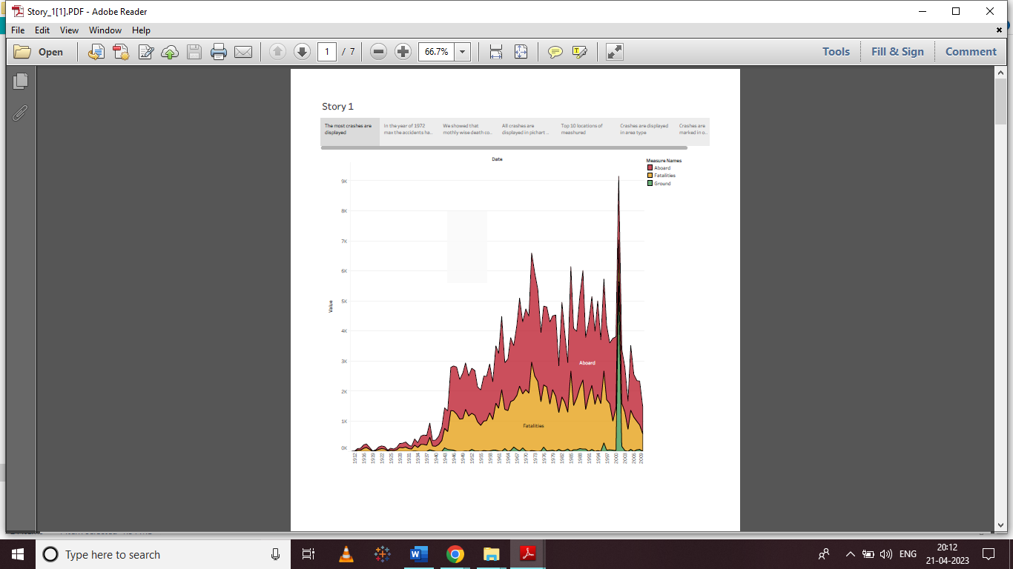

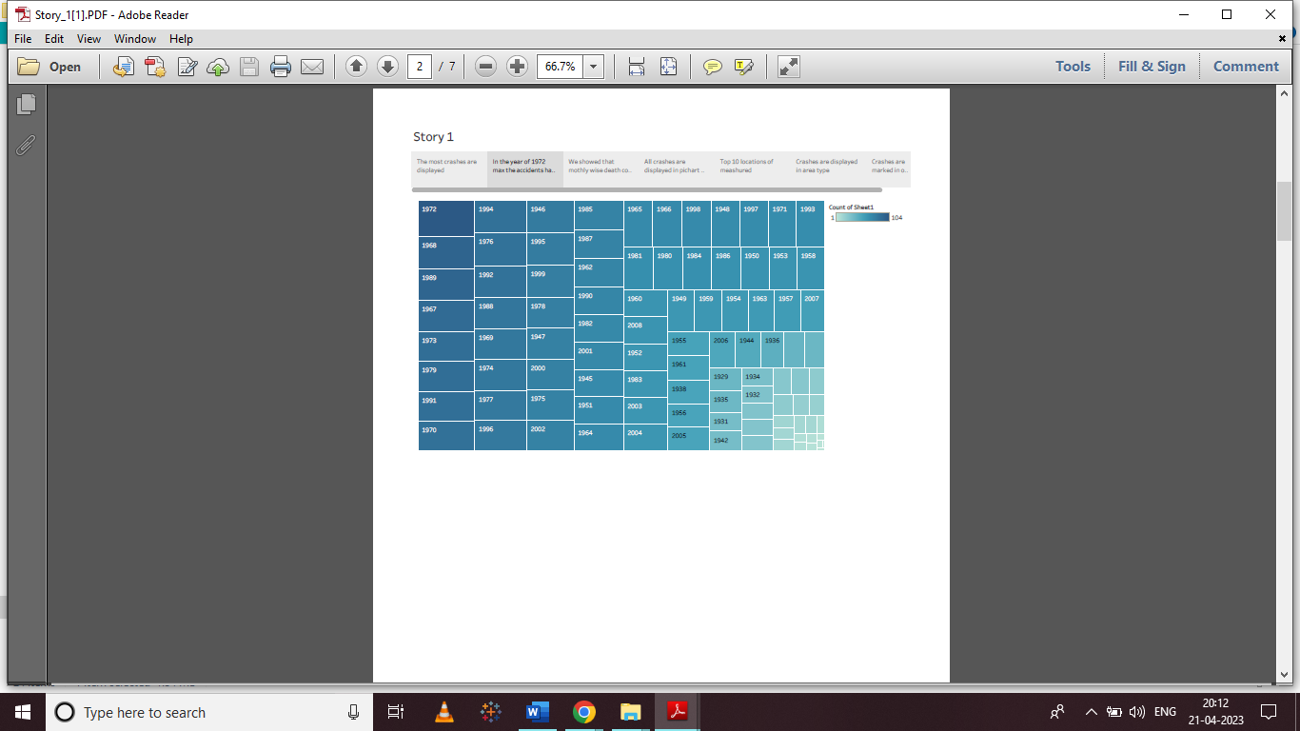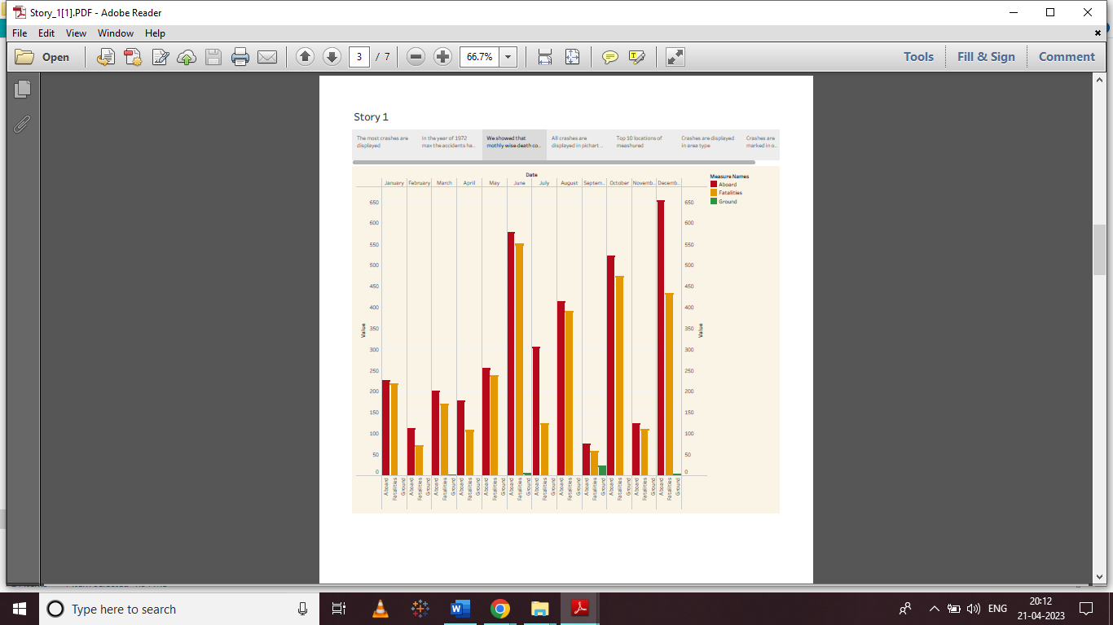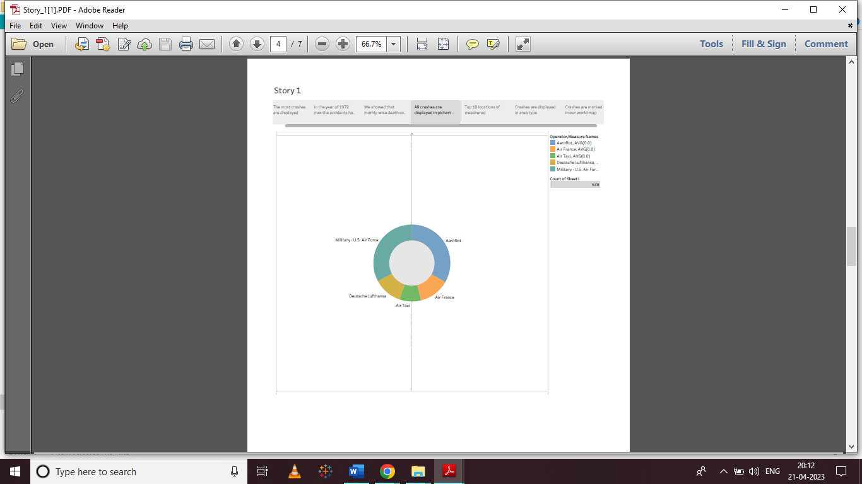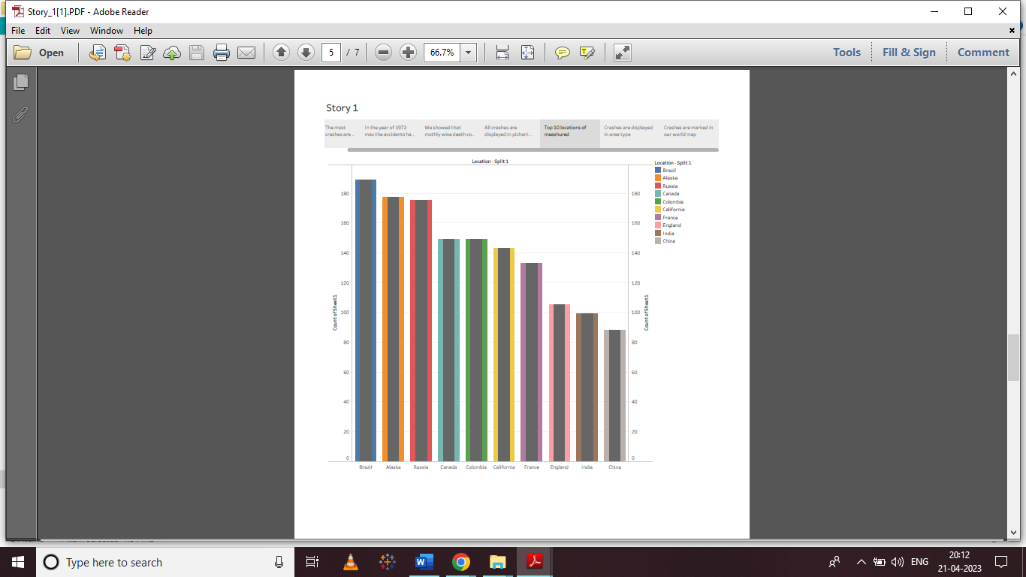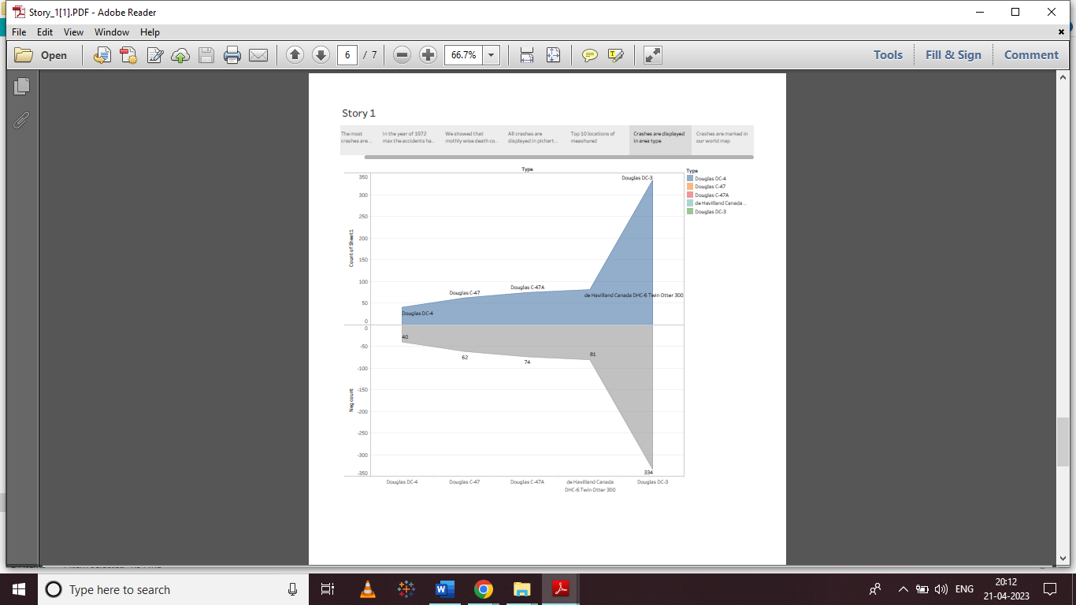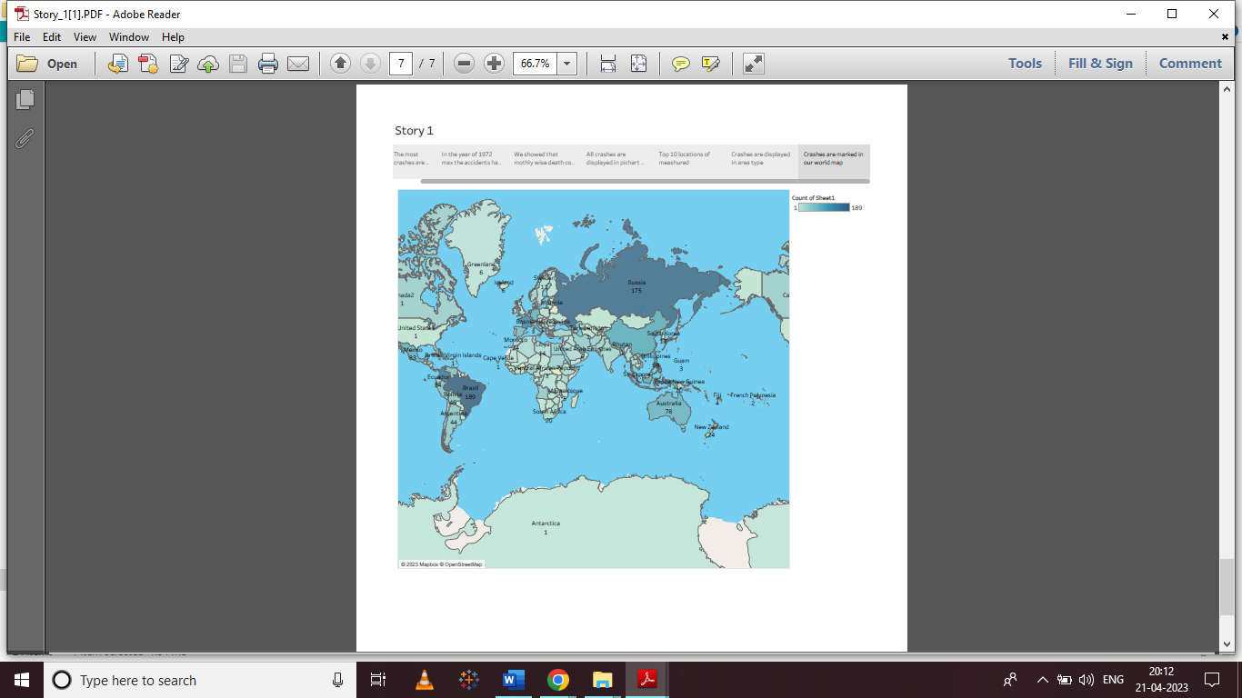

4.ADVANTAGES AND DISADVANTAGES

ADVANTAGES

* Long distances
* Higher Cost
* Less storage capacity
* Restrictions on goods
* No physical Limits
* Very reliable transportation

DISADVANTAGES

* It is more expensive than other types of transport because fuel is expensive. ...
* It has capacity limits. ...
* It is more polluting than other more sustainable means of transport such as electric vehicles.

APPLICATIONS

The broad spectrum of uses for airplanes includes recreation, transportation of goods and people, military, and research.

  Worldwide, [commercial aviation](https://en.wikipedia.org/wiki/Commercial_aviation) transports more than four billion passengers annually on [airliners](https://en.wikipedia.org/wiki/Airliner)and transports more than 200 billion [tonne](https://en.wikipedia.org/wiki/Tonne)-[kilometers](https://en.wikipedia.org/wiki/Kilometer) of cargo annually, which is less than 1% of the world's cargo movement.

Most airplanes are flown by a pilot on board the aircraft, but some are designed to be [remotely or computer-controlled](https://en.wikipedia.org/wiki/Unmanned_aerial_vehicle) such as drones.

6**. CONCLUSION**

The airplane was inspected and maintained in accordance with EIAI and Boeing maintenance procedures. The flight crew was trained and certificated in accordance with appropriate Israeli CAA, EIAI, and industry standard procedures.

At an altitude of about 6,500 feet the no. 3 pylon failed, this pylon and no. 3 engine separated from the right wing. The no. 3 engine struck the no. 4 engine, causing the no. 4 pylon and engine to separate from the wing. The leading edges flaps and a portion of the fixed leading edge of the wing back to the front spar were extensively damaged. The no. 3 and 4 hydraulic systems were completely and the pneumatic system was partially disabled.

The flight crew reported a fire on the no. 3 engine to ATC. Given the system logic a fire warning may have been the result of a double fault indication of the system.

**7.FUTURE SCOPE**

Mobility and its pillars of transport (air, inland and maritime) are at the very center of our socio-economic fabric. They underpin social connections and facilitate access to goods and services, including trade, jobs, health care and education. In today’s world, mobility by air, road and water is all about efficiencies, speed, interconnectivity and accessibility by all. However, this raises the issue about sustainability. The UN predicts that by 2050 two thirds of the world population will live in cities 1.

In addition, innovation in technology and approaches (e.g. by redefining efficiencies in travel) are essential to redefining mobility. Cutting-edge technology, such as autonomous devices and ultralight materials, creates opportunities to transform the mobility system by enabling new business models and mobility services. Innovations abound in aviation, e.g. unmanned aircraft innovations; artificial intelligence; biometrics; robotics; block chain; alternative fuels and electric aircraft. Aviation is therefore ideally positioned to support the innovation discourse and its potential impacts on new mobility.

The World Economic Forum proposes that the deployment of these private sector and government innovations to address mobility challenges can contribute to an improved mobility landscape – if they are deployed in a coordinated and collaborative way that aims to optimize the entire transport system. Unfortunately to date, these efforts in many instances may be exacerbating transport issues, most notably by adding congestion and complexity while also creating inefficiencies between public and private modes of transport.